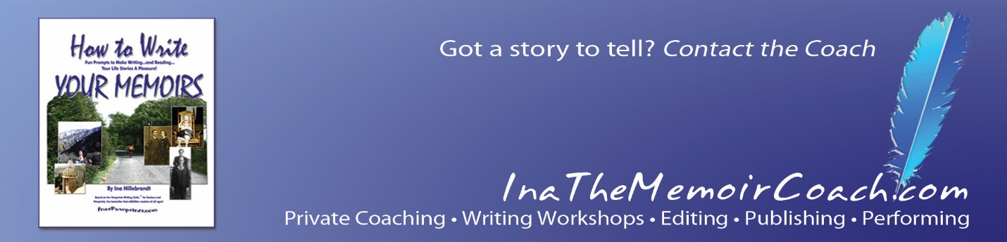
A recovering Fortune 500 consultant, Ina changed course (after being beaten up by her muse) to focus on writing and publishing. Her specialty now is helping folks create vivid, compelling memoirs. And getting their life stories out to the world, plus morphing their experiences into performance — for stage, screen, TV and web programming. Currently, she is also working on her first novel, a romance involving mice. Shhhhh. She hasn't told her cat Fiona yet.
More, from Ina….
It’s fun for me to work with clients and students from a wide range of backgrounds (for ex., Eliza, who grew up in India during the time of the Raj; Howard, a pilot and beekeeper who learned how not to be pantsed, thus keeping his purple shorts to himself; most recently, Lily, whose family was among the ruling folk in China, pre- and post-Mao).
From the beginning…Born and raised in Philadelphia, my late brother Conrad — former jazz critic of the San Francisco Chronicle and Swing Journal of Japan — spent half our kidhood living in Los Angeles after our parents’ divorce. Bi-coastal living wasn’t half bad, we decided; Burma Shave signs on Route 66 alone were a treat. At age 21, I graduated from the University of Pennsylvania (an anthropology major), and then ran away from both sets of parents to attend graduate school in New Orleans, at Tulane. There was a magical wedding in the French Quarter. Soon husband Barry, a lawyer who stopped to smell roses on the way to the office (among the many things that captivated me), and I drove to Manhattan with our first child, Rapscallion P. Cat, to seek our fortunes.
Barry wound up heading Contracts for the Today and Tonight shows at NBC, while I started learning the ropes of being a focus group moderator at J. Walter Thompson. When our daughter Nicole was born, I took a leave of absence and decided to become an independent consultant so that I could spend time at home to be with “The Tot.” Work expanded, and by the time Nicole was three, Hillebrandt Consultants had grown into a full blown consulting business in strategic research and planning, counseling Fortune 500 companies and non-profits around the country on trends, new products and communications.
In the mid-eighties, I had several epiphanies. There was a divorce, a move to Connecticut, and then a return to first love – California, with Nicole, two cats and Handsome, the World’s Best Dog in tow. First living in Marin, and later Berkeley and Carmel, I am now based in Los Angeles, and happy to add that Nicole is nearby after her own forays into exotic locales including Firenze.
Not long after re-entry into the Los Angeles of my youth, my book Pawprints got published. Its debut was held at the Los Angeles Zoo, where I was billed as Homo Sapiens Authorensas, with a sign cautioning visitors “Please don’t feed the Authorensas. She thinks she’s too fat as it is.” The book surprised this Authorensas, appealing to kids as well as adults, and I wound up creating a literacy program based on exercises developed for a workshop for educators for the Jane Goodall Institute. Using Pawprints’ tales of close encounters of the furry kind to interest kids in reading, and writing, the program, Pawprints Literacy Plus™, improves literacy skills and reinforces the importance of kindness to animals, the environment and each other; it’s in use in different parts of the U.S., and we’ve had inquiries about programs for other countries as well.
Before writing Pawprints, which became an Amazon.com top seller, I’d contributed to other books, written articles and edited and written for newsletters, appeared in print in papers including the New York Times and The LA Times, on camera and mic on a range of radio, TV and video programs.
Now, as you know, my personal focus is on helping adults write, and morph projects where warranted into live and film/TV/web video programs. I work as a writing coach, specializing in memoirs, and on TV/film content development. If you’re interested in creating or refining your own memoirs, you can find me leading live classes, and as a private coach for help with writing, editing and publishing memoirs, by phone and virtually. Just send a note to me at https://InaTheMemoirCoach.com.
Current projects: To be released May 30, How to Write Your Memoirs, Expanded Edition, Vol. 2. Also working with author Chester L. Richards on the second of his planned series of books, and involved in PR with The Black Chateau to promote his lively and compelling first book, published under my Pawpress imprint: From The Potato to Star Trek and Beyond: Memoirs of a Rocket Scientist. And there’s the first novel, the story about mice. Little devils are raising a ruckus about what happens next.
If you'd like to know more about Ina's background and work, please visit her original site: https://InasPawprints.com.
200 S. Barrington Ave. Ste. 492213 Los Angeles, CA
http://InaTheMemoirCoach.com

